

I N V O I C E

No 1931-19

Sept 10, 2019

Bill To: NSA NYC

Pay Pal Commission Charged on reimbursement
For Baruch College Rental Deposit (Palooza)
Exhibit 1 $ 47.98

Pay Pal Commission Charged on reimbursement
For Baruch College Rental Balance Due (Palooza)
Exhibit 2 111.54

Express Mail fee on Check sent to Baruch College
For Palooza
Exhibit 3 28.30

Handout printing for Luncheon
Exhibit 4 76.21

Design fee for cards distributed at Luncheon
Exhibit 5 250.00

Print fee for Cards distributed at Luncheon
Exhibit 6 87.90

Total $ 601.93

Please remit to:
The Townsend Group, Inc
570 W 156th St, Suite 26
NY, NY 10032
914-213-3122
Exhibit 1

Exhibit 2

Exhibit 3

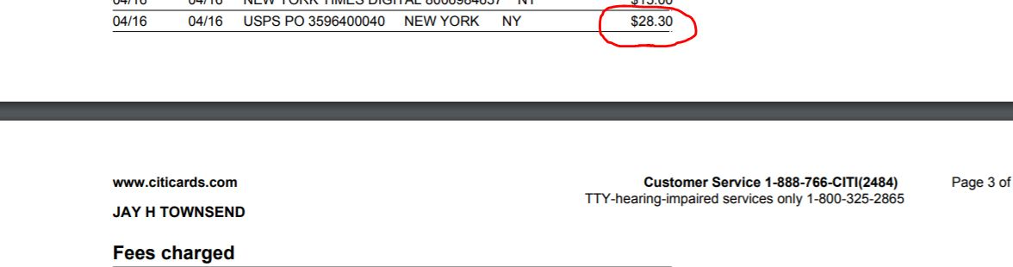

Exhibit 4

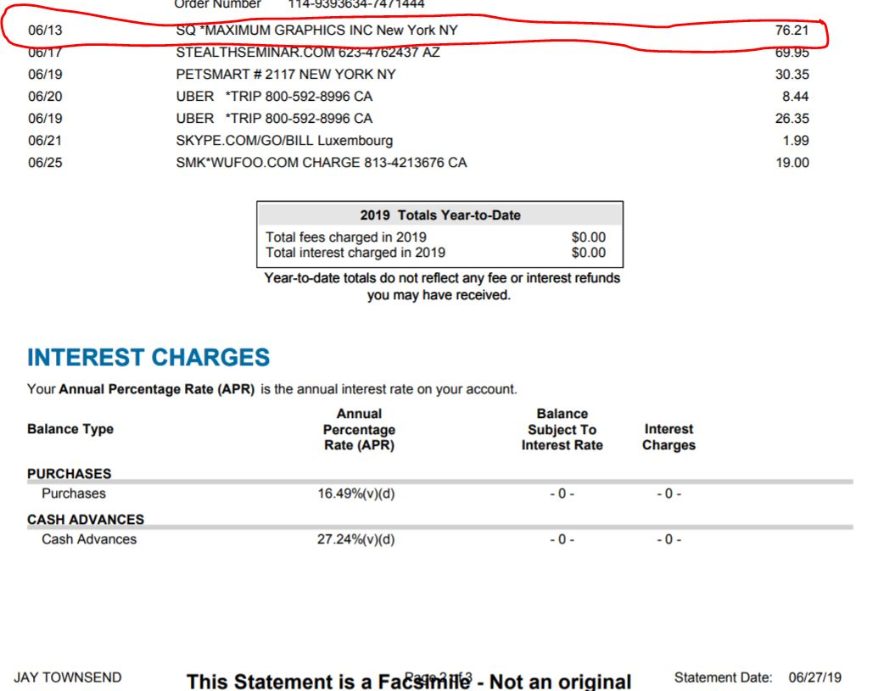

Exhibit 5
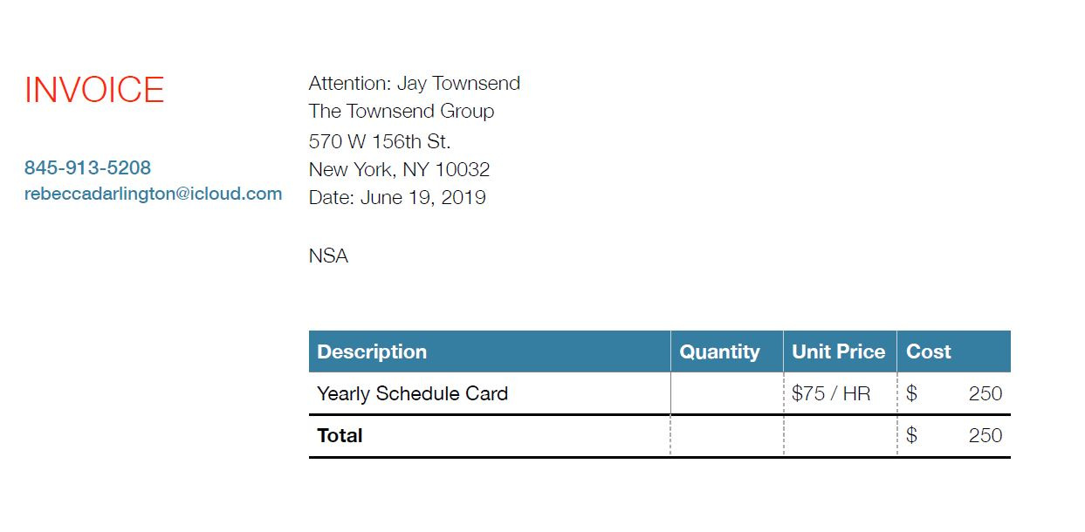

Exhibit 6


